Eurécia Single Sign-On (SSO)
Setting up SSO with ADFS

Glossary:
Name
IDP | Identity Provider: your company’s ADFS (or similar product) which provides your authenticated user access
SP | Service Provider: the Eurécia application
AD | Active Directory
Hardware requirements:

Minimum configuration
Windows Server version | Windows Server 2008 Enterprise or later
Memory | 2 GB RAM
Disk space | At least 10 GB

- Install and configure the software required
Software/Service | Action | Description | Link
IIS (Internet Information Service) server | Use the Server manager to add the “Web Server (IIS)” server role | This server is needed to provide the web pages

1

ADFS 2016 | Use the Server manager to add the ADFS role | This is the Identity Provider that will provide the user identities from the AD data | https://docs.microsoft.com  /en-us/windows- server/identity/ad-fs/ad-fs- deployment  https://docs.microsoft.com  /en-us/windows- server/identity/ad- fs/deployment/set-up-the- lab-environment-for-ad-fs- in-windows-server-2012-  r2

Creating a self-signed certificate using the IIS server (optional)
The purpose of this step is to ensure that SSL is activated. If it already is, you can ignore this step.
  - Open the IIS manager from the console (Start menu > IIS manager
  - Double-click the “Server certificates” icon. See the red box in the following screen capture:

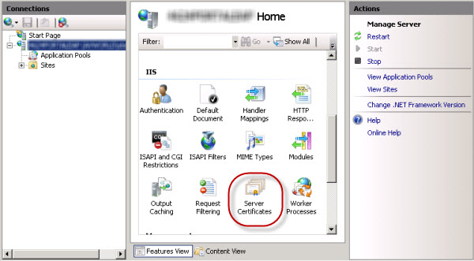

2

  - In the “Actions” pane, click “Create self-signed certificate”. See following screen capture:

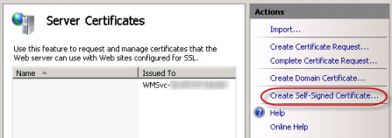

  - In the “Specify a friendly name for the certificate” field, enter your server’s FQDN (Full Qualified Domain Name)
  - In the same view’s “Connections” pane, click “Default Web Site” and then, in the “Actions” pane, click “Bindings”

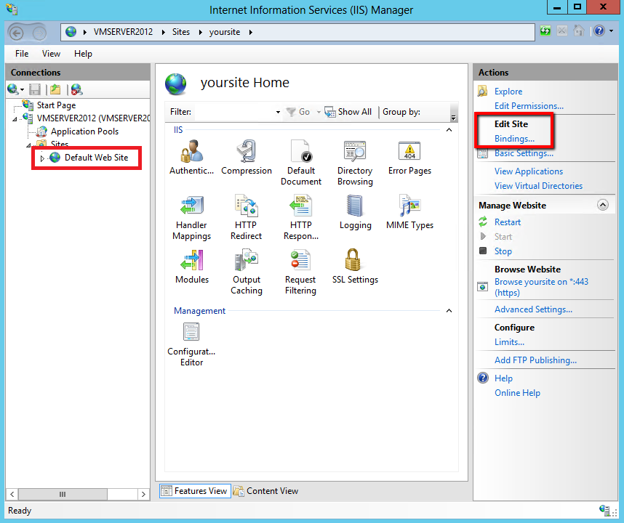
  - Next, click the “Add” button and then, in the “Type” value list, select “https”.
  - In the “Certificate” field, select the name of the certificate that you created earlier. Finish by clicking “OK”

3

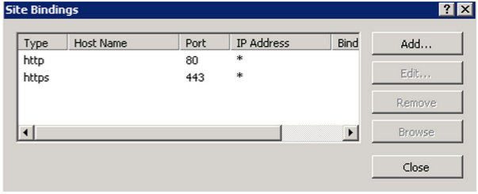

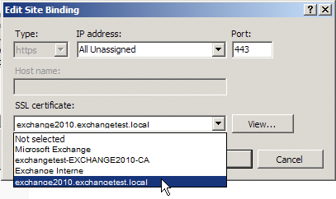

4

Configuring the ADFS 2016 server
  - In the home page, type “AD” and then select “AD FS management”

  - In the home page’s “Actions” (right-hand) pane, click “Add Relying Party Trust”

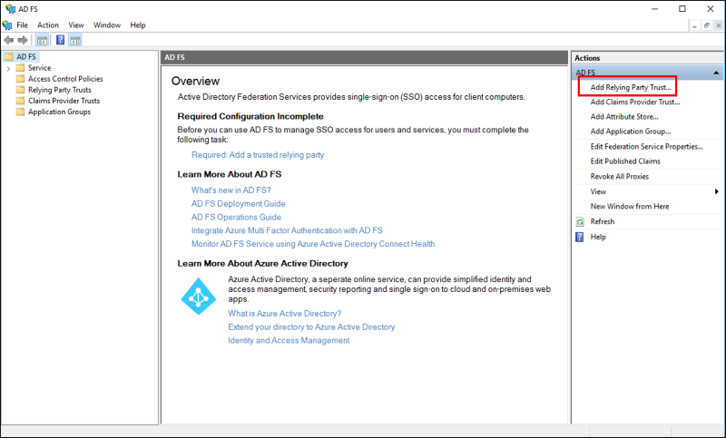

In the window that opens, click the “Welcome” button and then select “Import data about the replying party published online or on a local network”

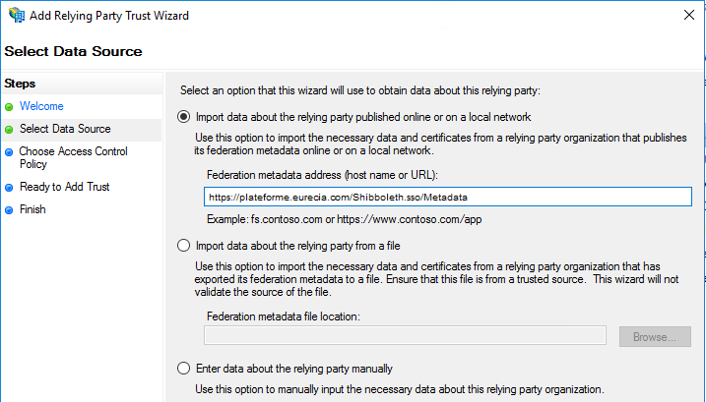

5

The URLs are in the following form:

https://EuréciaServerAddress/Shibboleth.sso/Metadata

The EuréciaServerAddress part of the URL depends on which Eurécia server you want to connect to via SSO.

For example, to connect to the Eurécia production platform via SSO, the URL is:
https://plateforme.eurecia.com/Shibboleth.sso/Metadata

For the demo platform, the URL is:
https://demo.eurecia.com/Shibboleth.sso/Metadata

If you see the following error message:

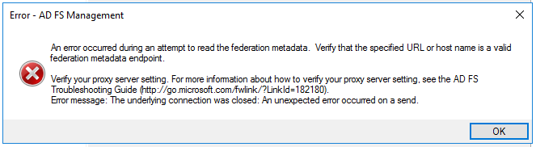

your ADFS is probably unable to negotiate the proper HTTPS protocol with our site – we accept TLS 1.1 or later.

If you see the following message, you can ignore it and simply click “OK”
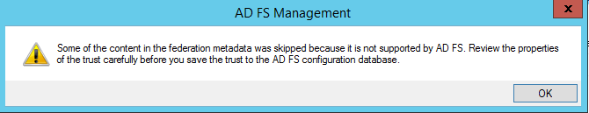

  - In the next window, leave the prefilled full name unchanged (it must be in the form of XXX.eurecia.com) and then click “Next”

  - Select “Permit all users to access this replying party” and then click
“Next”.

6

  - A summary of the information entered is displayed. Click “Next ”.

  - Leave the “Open the Edit Claim Rules dialog for this replying party trust when the wizard closes” checkbox selected in the next window and then click “Close”.

  - A new window is displayed. Click the “Add rule” button.

  - In the value list, select “Send LDAP Attributes as Claims” and then click “Next” (see screen copy).
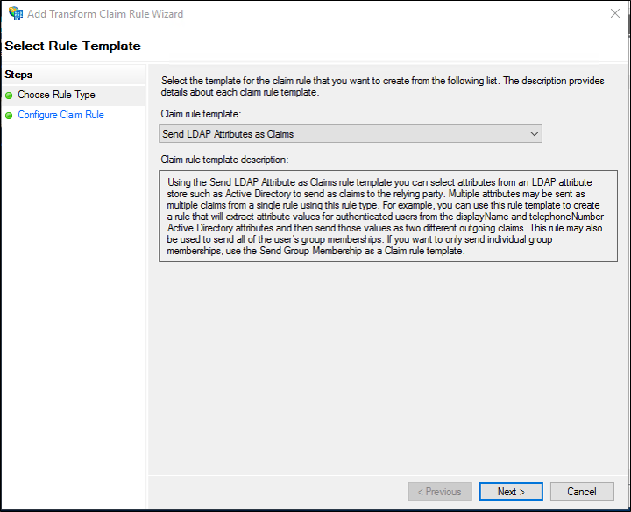

7

    - Type GetEmail in the “Claim rule name” field. In the “Attribute store” field, select “Active Directory”. In the “Mapping of LDAP attributes to outgoing claim types” section”, select the values shown in the following table:

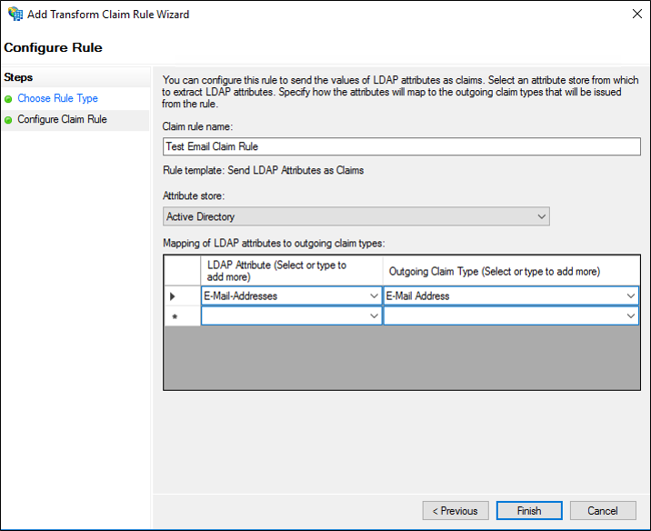

- Click the “Finish” button
- Open an internet browser and then enter the following URL (the URL may differ depending on your version of ADFS):

https://localhost/FederationMetadata/2007-06/FederationMetadata.xml

Note: the URL used to access your ADFS may be displayed instead of localhost

- Save the generated XML file on your Desktop, naming it IDPFederationMetadata.xml

You have now finished setting up identity federation from your Active Directory. You now only have to send the IdpFederationMetadata.xml file to the Eurécia customer support team at support@eurecia.com

8

Setting up acceptance testing
- Testing requirements:
  - Eurécia’s employee database of identified users must be installed.
  - The metadata file must have been sent to Eurécia (Step k. of the “Configuring the ADFS 2016 server” section)
- Create a shortcut for making a test sign-on from the client workstation: https://demo.eurecia.com/Shibboleth.sso/Login?target=https://demo.eurecia.com/eurecia/s ecureshib&entityID=http://url.access.adfs/adfs/services/trust
url.access.adfs = URL used to access your ADFS

demo.eurecia.com = the Eurécia platform address used to set up the SSO connection

Note: The method using a shortcut to test the sign-on may cause a redirection error, depending on which browser is used and how your ADFS is configured.

This is because the first time you sign in, you will be asked to enter your Windows username and password. When you do so, the browser may “forget” the dialogue that it had previously with the Eurécia platform and therefore not send all the necessary information to your ADFS.

In this case, simply run the shortcut again – as the username and password have already been saved, you will be able to sign in without any problem.

Setting up employee database provisioning via FTP (optional)

This section explains how to set up LDAP directory synchronisation with the Eurécia employee database. This synchronisation will be carried out using a file in a special format defined by Eurécia (see following shell script). This file will be placed in an FTP repository (Eurécia must be told the login/sign-on details to enable us to configure the job).

From Windows, create a shell script that runs a scheduled task at the intervals you specify. The output file will be placed in an FTP repository (overwriting the previous copy there)

Get-ADUser -Filter { memberOf -RecursiveMatch "CN=EURECIA,CN=Users,DC=XXXX,DC=com" } -Properties emailaddress | Select @{Name="LASTNAME";Expression={$_.Surname}},@{Name="FIRSTNAME";Expression={$_.GivenName}},@{Name="EMAIL_USER";Expression={$_.emailAddress}} | Convertto-CSV -Delimiter ";" -NoTypeInformation > "c:\temp\fichierOut.csv"

Eurécia must configure the data transfer module that will regularly retrieve the data (in the special format defined by Eurécia) from an FTP/sFTP repository and update the employee database:

9

Whenever a new employee is created
o

- Whenever an employee’s information is updated

- Whenever an employee is archived upon leaving the company

Frequent problems

Some Windows Server versions may cause redirection problems during the authentication phase.
This problem results in a “web page unavailable” error message.
Update: Install update 2896713

10

